# Setting up EEGLAB for analysis.

1. Open EEGLAB

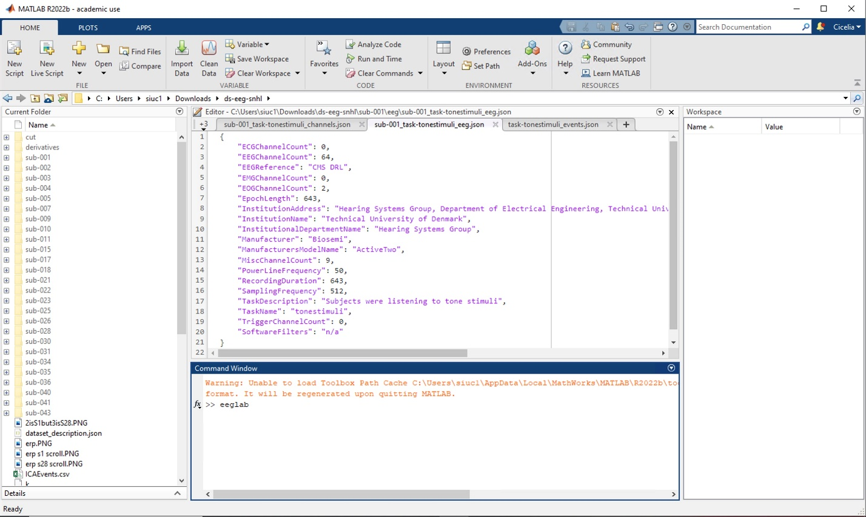

1. The following window should appear.

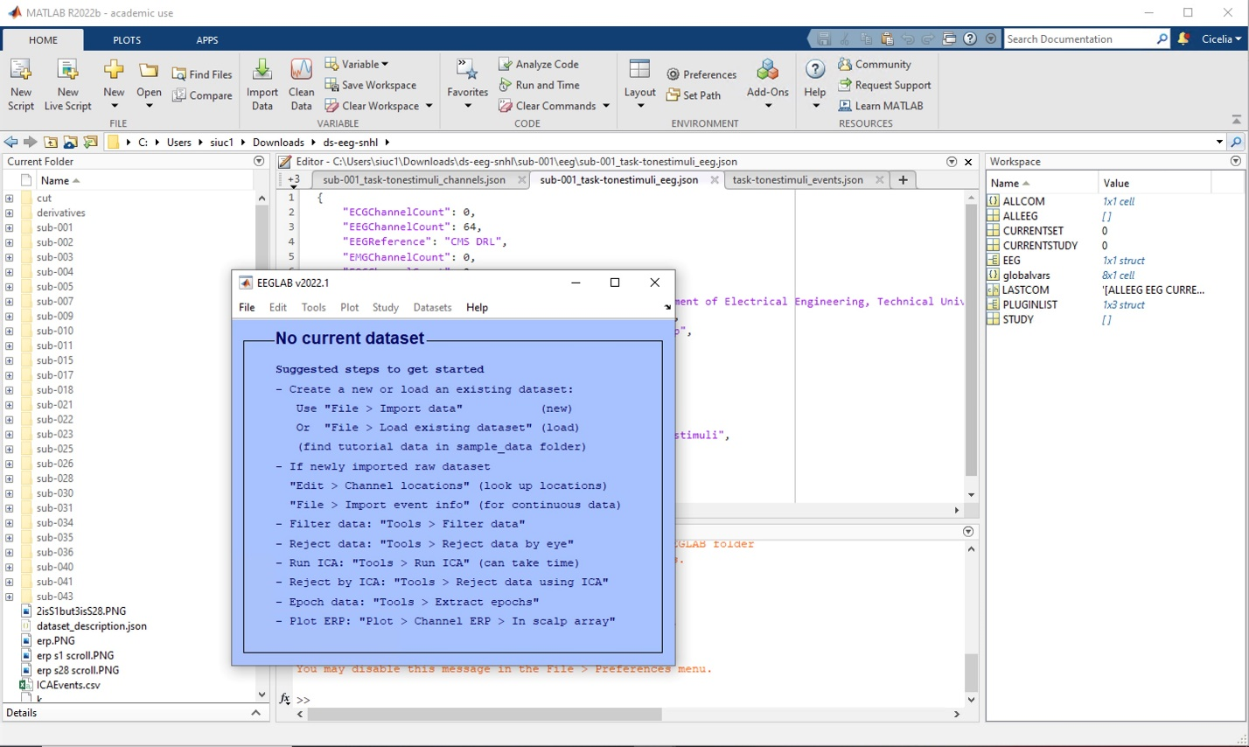

1. Open a BIOSIG file (.EDF or .BDF file) using the following photos.
   1. Channel list is an optional parameter to choose specific channels to look at instead of all of them
   2. Data range refers to the seconds within the data to choose from (used often).
   3. 48 is the channel number for Cz, the electrode channel at the very top of the head.
   4. Leave the rest as the default.

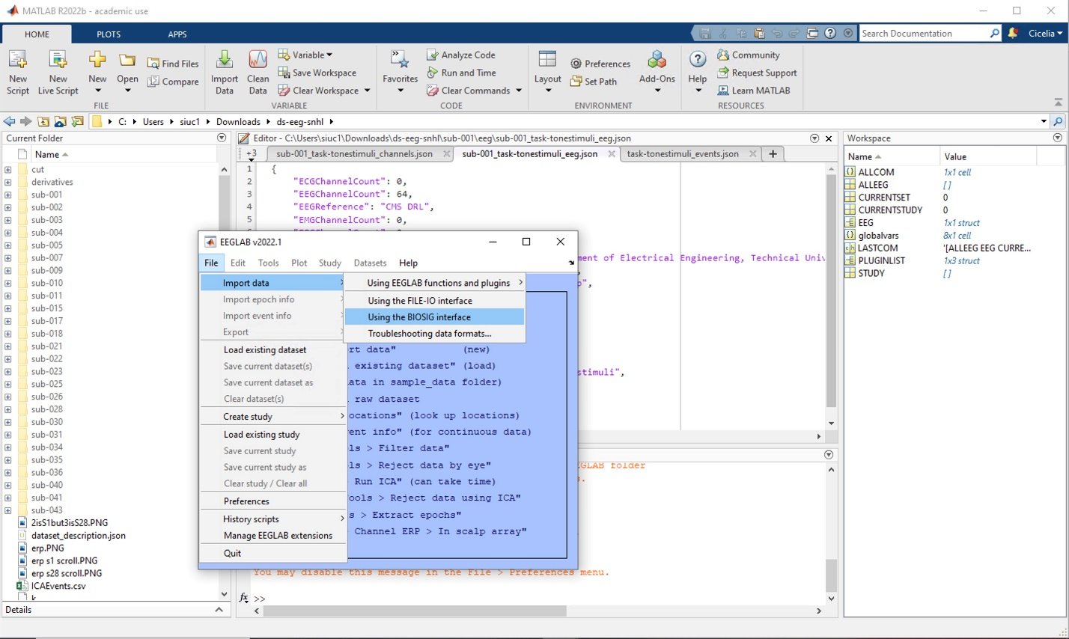

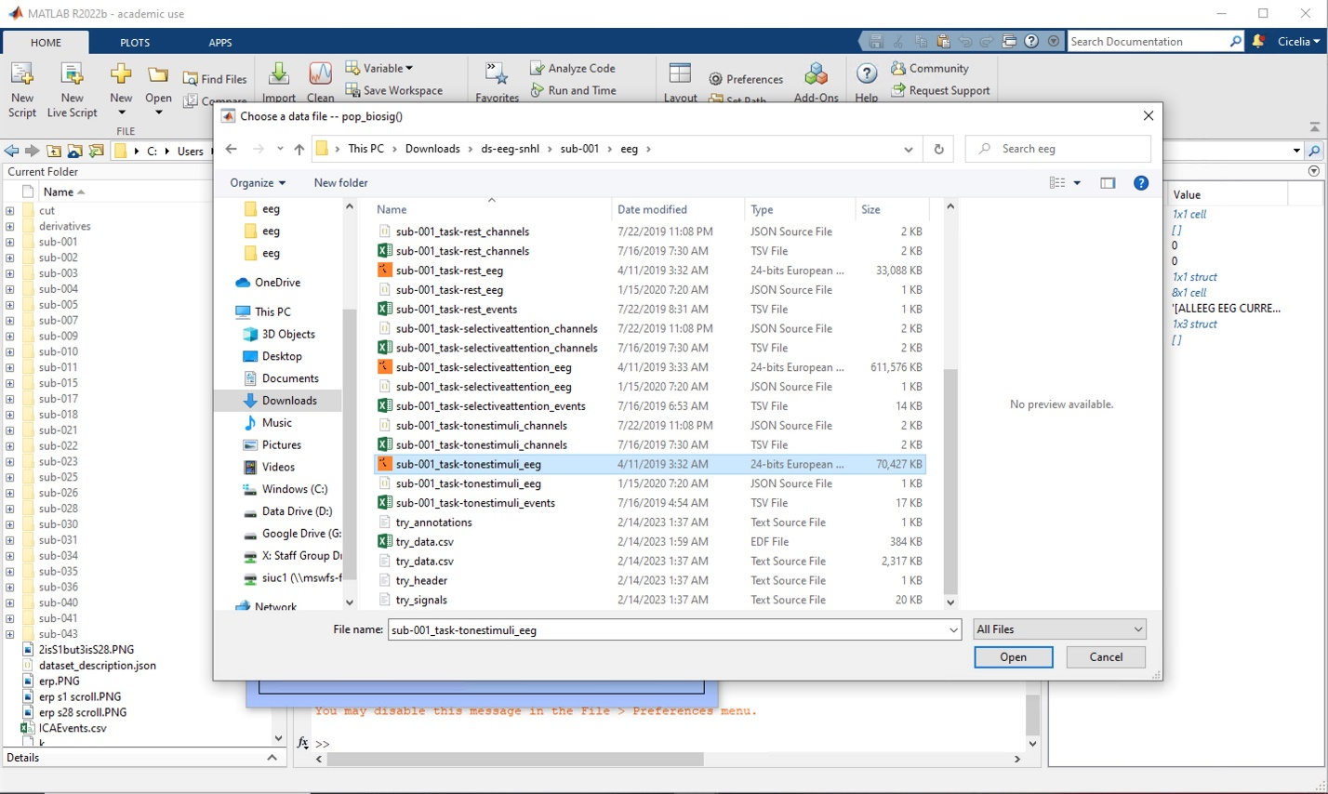

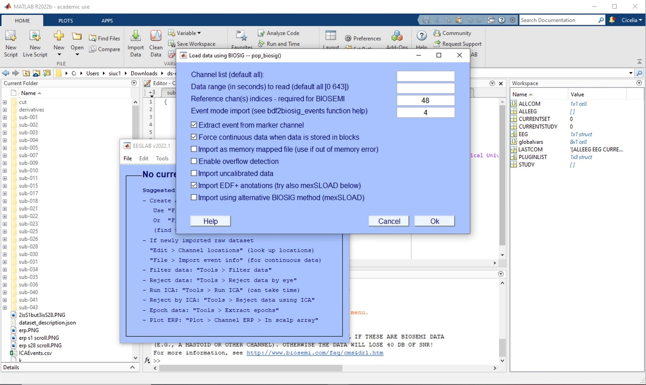

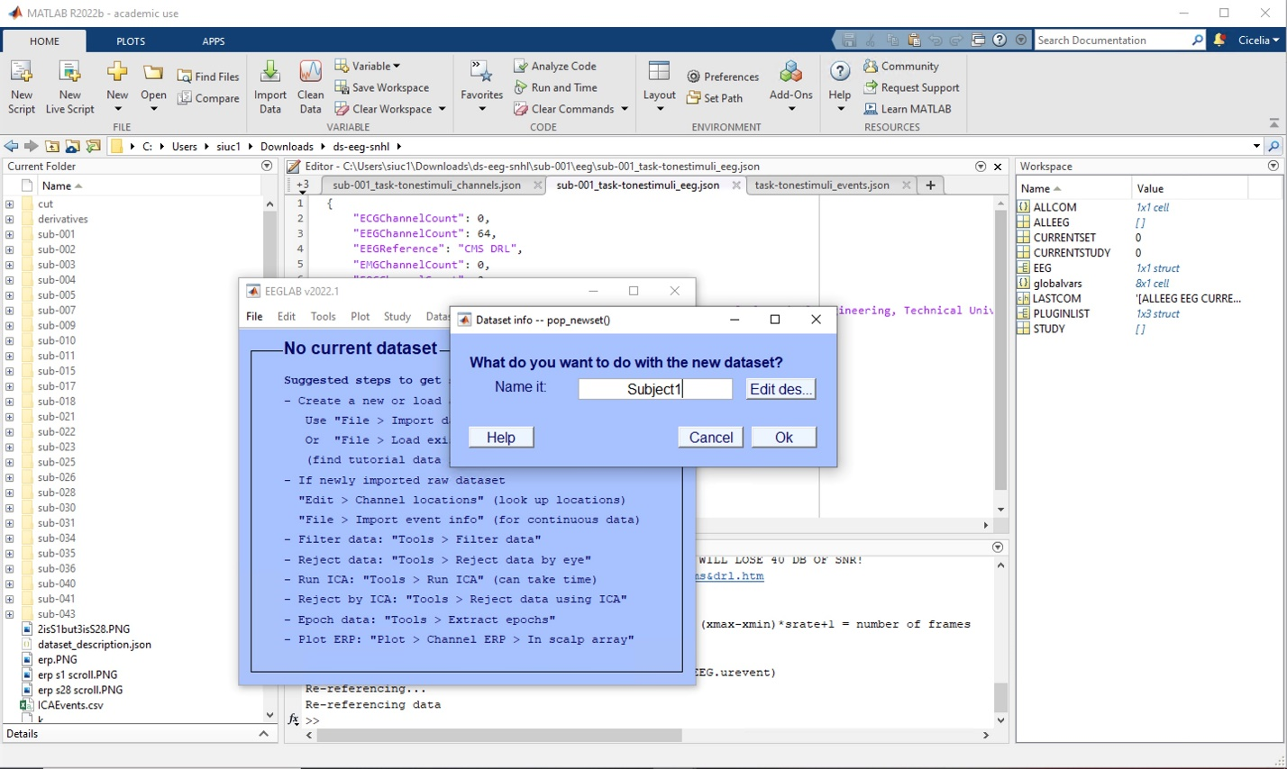

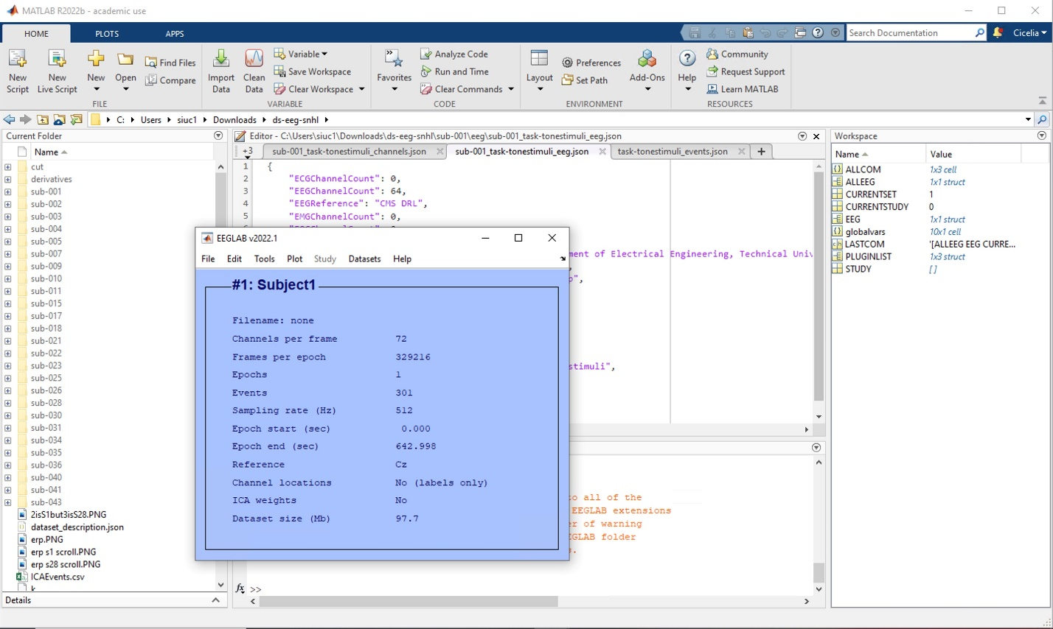

1. Update channel locations for plotting purposes using the following photos.
   1. It should result in the channel location changing from “No (Labels only)” to “Yes”
   2. Not doing this step will result in not being able to see the spectra maps.

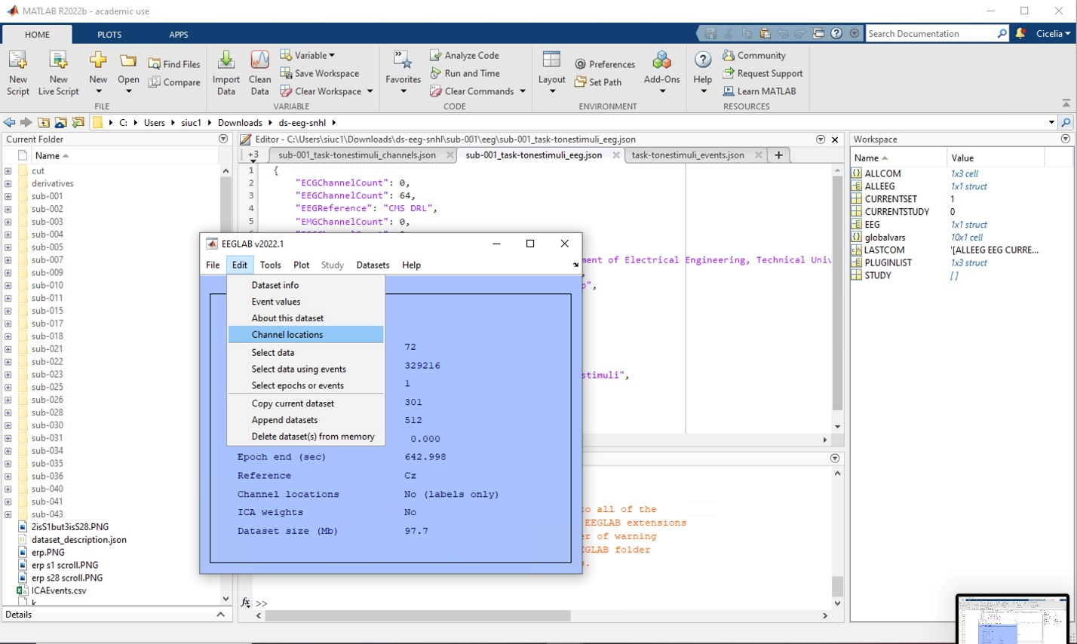

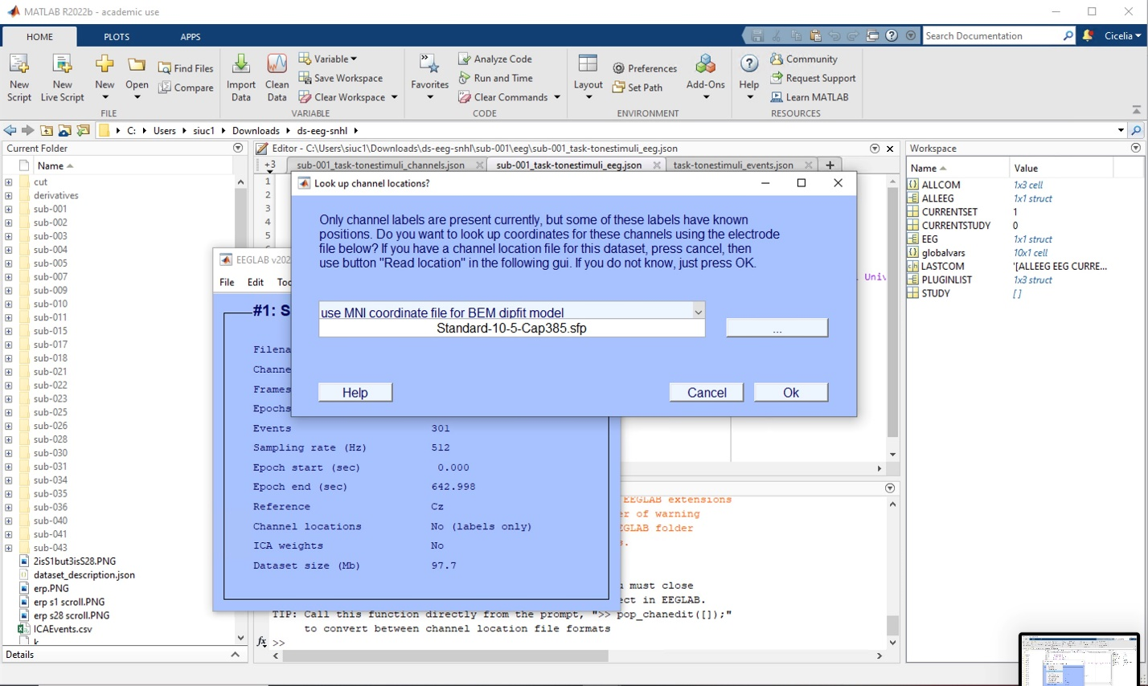

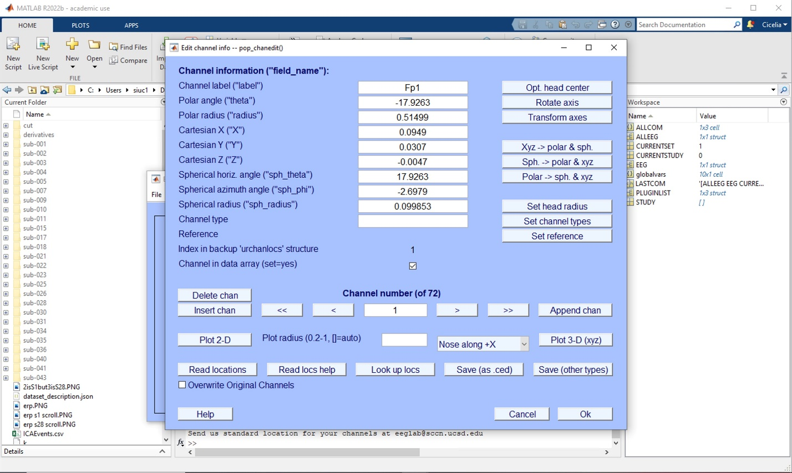

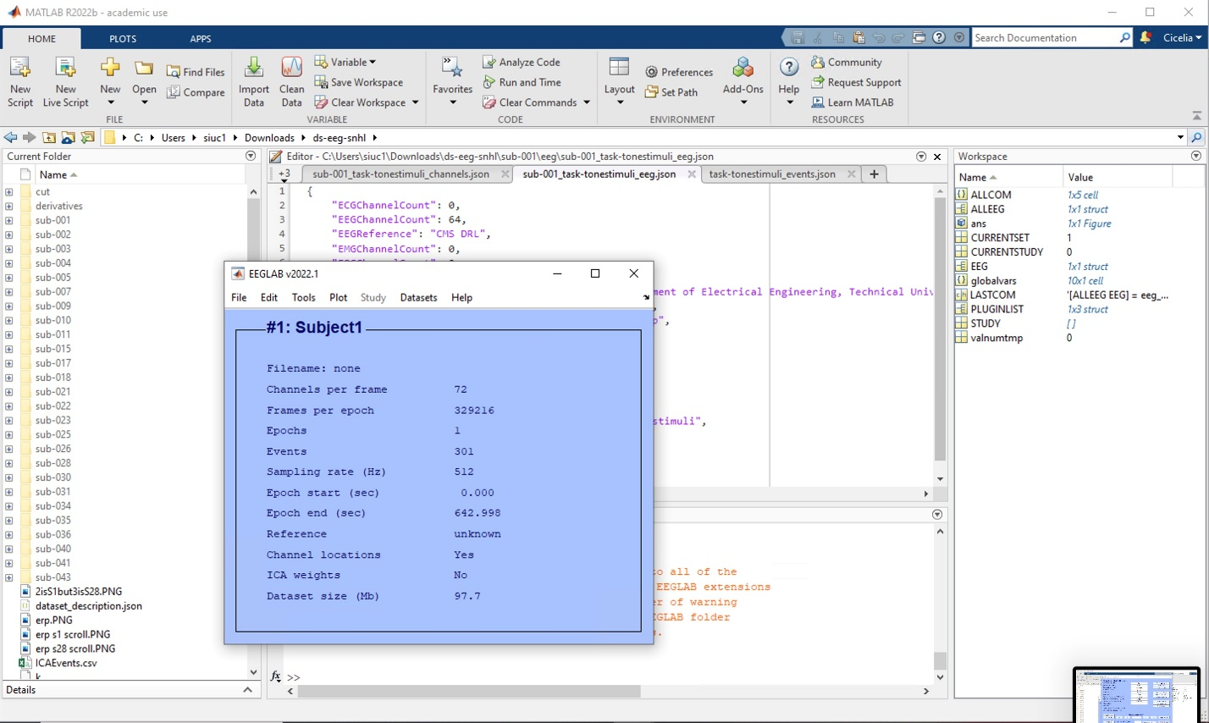

# Three different plots

1. Plot channel locations using the following photo. It should result in a photo from the top of the head that plots the electrode locations.

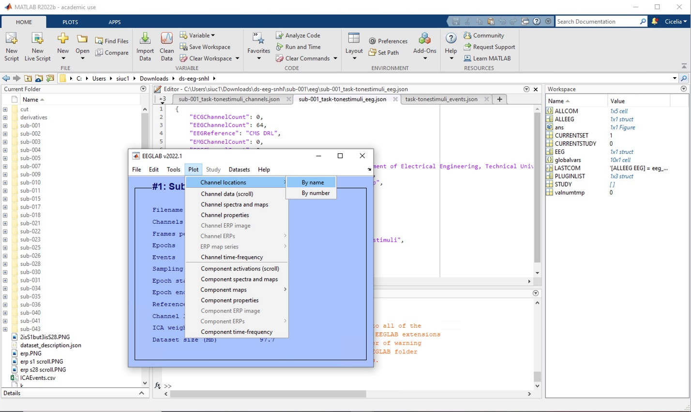

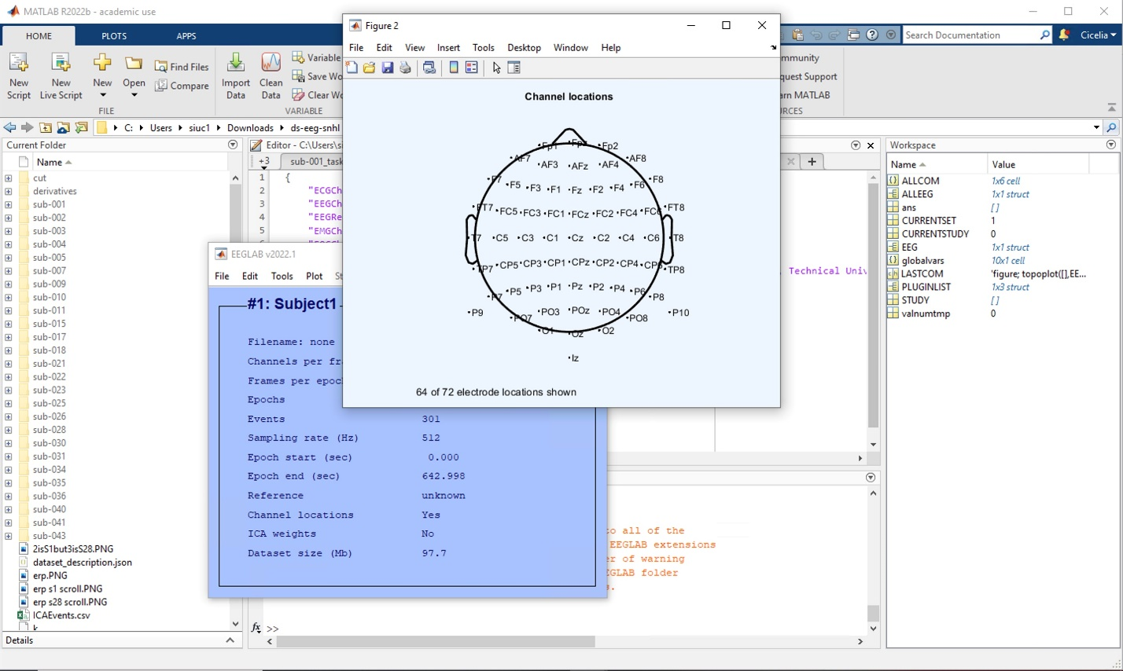

1. In the Plot > Channel Data (Scroll), the following plot will appear.
   1. The x axis refers to the seconds within the data. The y axis refers to the channel names.
   2. The vertical colored lines are events. Scrolling to the right will show more events.
   3. Bring up an event legend using Display > Events Legend.
   4. Explanations of the plot legend will be in the .JSON file

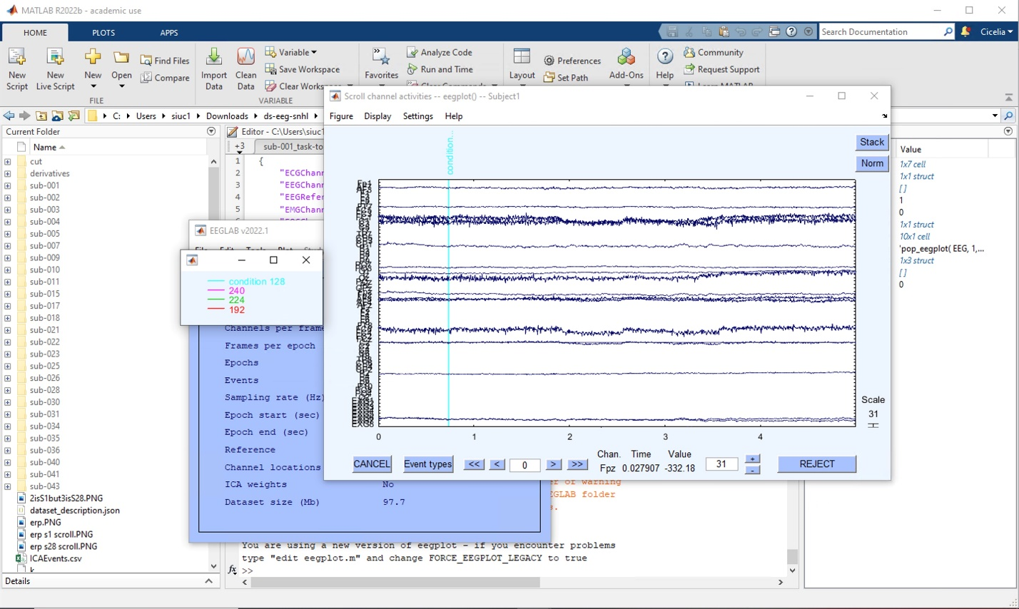

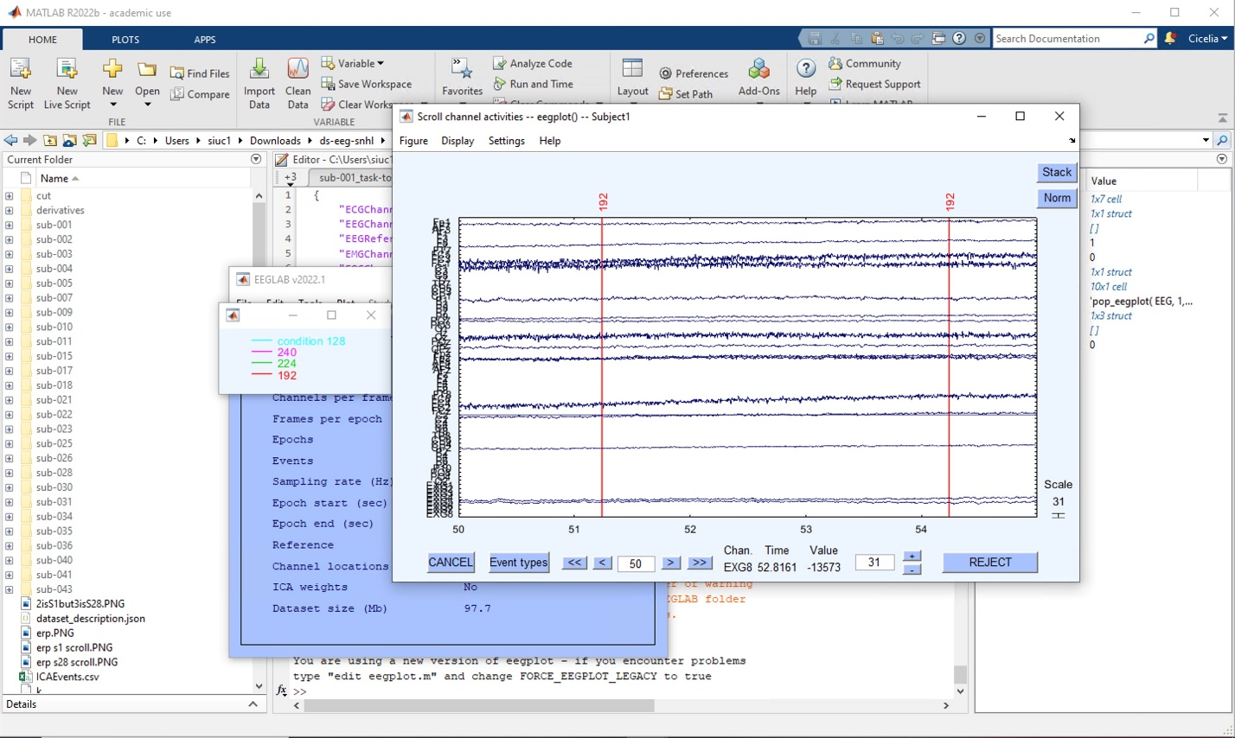

1. In Plot > Channel spectra and maps, the following will appear.
   1. Add or delete the Hz depending on what is needed
   2. Change the frequency range as needed, but not needed in this case.

